**Unit 1 Can you play the guitar?**

**词汇精讲**

**1. speak**

speak，say，talk和tell的用法归纳：

1. speak 既可以作不及物动词也可以作及物动词，它的意思是“说、讲话”，作及物动词的时宾语是某种语言。

例如：My father is speaking. 我的爸爸在讲话。（不及物动词）

My sister can speak French. 我的姐姐会说法语。（及物动词）

2）say是及物动词，它的意思是“说”，后面要有说的内容。

例如：I have to say sorry to the teacher. 我不得不向那位老师道歉。

Can you say it in English? 你能用英语说吗？

3）talk意为：“交谈、谈论”，常作不及物动词。后面用介词to/with, 表示“与……谈话/交谈”；接介词about 时表示“谈论……”；接of时表示“谈到/起……”。

例如：What are you talking about? 你们在谈论什么？

Who are you talking with? 你在和谁谈话？

1. tell的意思是“告诉、讲述”，经常用动词短语tell sb. sth. 表示“告诉某人某事”或tell sb. to do sth. 表示“告诉某人做某事”。

例如：Please tell your brother not to swim here. 请告诉你弟弟不要在这里游泳。

My grandmother often tells me some stories. 我的奶奶经常给我讲故事。

**2. or**

or来连接两个（或多个）并列成分。在否定句中表示“和”的时候，通常用or。此时，只在or前面的列举项前加no或者not， 但是如果要用and连接，则and前后的列举项都要加not 或no。

例如：Do you like rice, milk, apples or bananas?

你喜欢米饭、牛奶、苹果或香蕉吗？

I have friends, but I have no sisters or brothers.

= I have friends, but I have no sisters and no brothers.

我有朋友，但是我没有兄弟姐妹。

**3. be good at**

be good at 意为“擅长……”， at是介词，后面可以接名词、代词或动名词。

例如：I’m good at English. 我擅长英语。

Tom is good at playing football. 汤姆擅长踢足球。

**【拓展】**be good at 相当于词组do well in，在句子中常可以互换。

例如：She is good at Chinese. = She does well in Chinese. 她汉语学的好。

**4. play**

1）play和球类、棋类等运动项目搭配时，表示“参与运动”或“进行比赛”，此时名词前不加任何限定性的词。

例如：She can play the piano. 她会弹钢琴。

I play basketball every day. 我每天都打篮球。

2）play与各种乐器搭配，表示“演奏；弹奏；吹奏”，此时乐器名称前往往会加上定冠词the。

例如：play the drums 敲鼓 play the piano 弹钢琴 play the violin 拉小提琴

3）play还用作不及物动词，意为“玩”。

例如：Let’s go to play on the playground. 我们到操场上去玩吧。

Don’t play with fire. 别玩火！

4）play用作名词，意为“戏剧”。

例如：I like watching TV plays. 我喜欢看电视剧。

**5. join**

1）join 意为“参加，加入”，可以指加入某种社团或者组织，成为其中的成员。

例如：Yao Ming joined the NBA. 姚明加入了NBA。

2）“join + 指人的名词或代词”，意为“加入……之中”。

例如：Will you join us for lunch? 和我们一起吃午饭好吗？

3）“join + in + 活动类名词”意为“参加……（活动）。”

例如：Can you join in the game? 你能参加这个游戏吗？

**6. also＆too**

1) also也，用在肯定句中间，位于be动词、助动词或情态动词后，行为动词前。

例如：We also like playing football. 我们也喜欢踢足球。

2) too也，用在陈述句末，常用逗号隔开。

例如：He has a lot of pen pals, too. 他也有很多笔友。

**7. make**

make是动词, 意为“使成为，制造”。

例如：make cakes 制作蛋糕

make常见的其他用法有：

1）“make friends”意为“结交朋友”；“make friends with sb.”指“和……交朋友”。

例如：We can make friends with them. 我们可以和他们交朋友。

2）“make sb. / sth. + *adj*./*v.*”意为“使某人……”。

例如：The good news makes us happy. 这个好消息使我们很高兴。

His story made us laugh.  他的故事让我们笑了。

**8. paint＆draw**

1）paint 做动词时，意为“给……涂色”，指用颜料画画，如水彩画或者水墨画。

例如：Please paint the wall green. 请把墙涂成绿色。

2）paint 做名词时，意为“油漆，颜料，绘画作品”。

例如：The paint is very popular. 这颜料很流行。

3）draw通常指用铅笔，钢笔或者粉笔画，一般并不涂上颜料。

例如：I like drawing. 我喜欢画画。

**9. show**

1）show 做名词，意为“表演，节目，展览”。

例如：a flower show花卉展览 on show 展览 a talent show 才艺表演

2）show 做动词，意为“给……看；展示”；常用结构是“show sb. sth. / show sth. to sb.”，意为“把某物展示给某人”。

例如：Please show me your ticket. 请出示您的票。

**词汇精练**

**Ⅰ. 英汉互译。**

1. 交朋友_______ 2. 弹吉他_______ 3. draw a picture _______

4. play chess______ 5. 说英语________ 6. 美术俱乐部_______

7. on show________ 8. be good at ______ 9. 参军________

10. have a swim ______

**Ⅱ. 根据句意、首字母或汉语提示，写出正确的单词。**

1. －Can you s______ French? －Yes, I can.

2. I c______ go to your birthday party. My parents ask me to see my grandparents.

3. He likes to play basketball. So he wants to j_____ the basketball club.

4. My sister can’t play the computer game o_____ chess.

5. I know a l_____ about English history.

6. Can you s______ your family photo to me?

7. Please come to Students’ Sports C______.

8. We n_____ help at the old people’s home.

9. They can t_____ you stories and you can help each other.

10. We w______ students for the school show.

**Ⅲ. 用括号内所给单词的适当形式填空｡**

1. Welcome you to join our ______ (swim) club.

2. He is a very______ player and he can play soccer very ______ (good).

3. He _______ (not like) the school show.

4. My sister likes singing and ______ (dance).

5. She likes music very much, so she is good at ______ (sing).

6. Jack’s father and mother are _______ (music).

7. Do you want _____ (join) the music club?

8. Can you ______ (show) me your picture?

9. Our teacher ______ (be) good at singing.

10. He is my favorite basketball ______ (play).

**IV.听力链接。**

**（2015 福建省福州中考）**

1. What present did Mary receive?

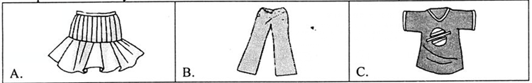

2. When will they meet?

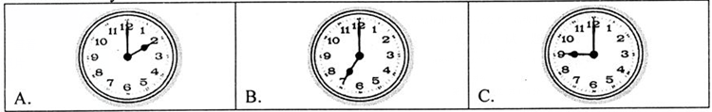

3. What’s Li Hong’s favorite subject?

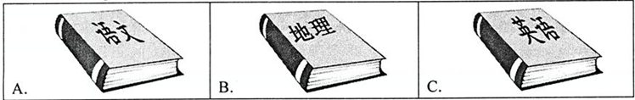

4. Which sport are they talking about?

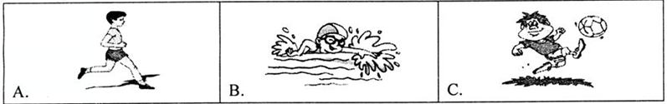

5. What did the boy’s mother cook for him?

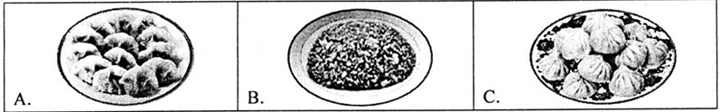

**参考答案**

**I. 英汉互译。**

1. make friends 2. play the guitar 3. 画画 4. 下国际象棋 5. speak English

6. art club 7. 展览 8. 擅长做某事 9. join the army 10. 游泳

**Ⅱ. 根据句意、首字母或汉语提示，写出正确的单词。**

1. speak 2. can’t 3. join 4. or 5. lot

6. show 7. Center 8. need 9. tell 10. want

**III.用括号内所给单词的适当形式填空｡**

1. swimming 2. good, well 3. doesn’t, like 4. dancing 5. singing

6. musicians 7. to, join 8. show 9. is 10. player

**IV.听力链接。**

参考答案及听力材料：

1. A 2.C 3.C 4. B 5. B

听下面五段对话，从题中所给的A、B、C三幅图中选出与对话意思相符的图。每段对话读两遍。

1. M: Mary, your skirt looks very nice.

W: Thank you. It’s my birthday present from my aunt.

2. M: Lucy, what time shall we meet tomorrow?

W: Let’s make it nine o’clock at the school gate.

3. M: Do you like geography, Li Hong?

W: Of course, but I like English best of all.

4. M: Swimming is a nice sport in summer.

W: So it is. But we must be very careful.

5. W: Wow, how delicious the fried rice smells!

M: My mom made it for me. She is good at cooking.

**句式精讲**

**1. Can you play the guitar?**

1）“Can +主语+动词原形+…？”可以译为“……会……吗？”。其肯定回答用“Yes, sb. can. ”；否定回答是“No, sb. can’t”。

例如：－Can you swim? 你会游泳吗？

－Yes, I can. 是的， 我会。

－No，I can’t. 不， 我不会。

这个句式的陈述句是: “主语+can / can’t+动词原形+….”。

例如：I can play football. 我会踢足球。

I can’t play football. 我不会踢足球。

这个句式的特殊疑问句是：“特殊疑问词+can +主语+动词原形+…?”。

例如：－What can you do ? 你会做什么？

－I can sing and dance. 我会唱歌跳舞。

2）“Can+ I / we+动词原形+…?”表示说话人请求对方的许可，询问“可不可以做某事”。

例如：Can you sing me a song? 你能给我唱首歌吗？

Can I use your book? 我可以用一下你的书吗？

**2. help sb. with sth.**

“help sb. with sth.”意为“帮助某人做某事”。此处的with是介词，后面可以跟名词。

例如：She helps me with my English. 她帮我学英语。

She helps her mother with housework. 她帮她妈妈做家务。

**拓展：**help 既可以做动词也可以做名词，常见的其他相关用法有：

1. help sb. (to) do sth. 帮助某人做某事 （动词）

例如：I often help my mother to do some housework.

我经常帮我妈妈做家务。

1. help oneself to sth. 随便（吃……） （动词）

例如：Help yourselves to some fish, children.

孩子们，请随便吃些鱼吧。

1. with one’s help 在某人的帮助下 （名词）

例如：With her help, I passed the exam.

在她的帮助下，我通过了考试。

**3. be good with…**

1)“be good with sth. / sb.”意为“善于……；精明的”。

例如：The teacher is very good with children. 这位老师对孩子很有一套。

2) “be good with sth. / sb.”还可以意为“和……相处的好”；此时和“get on well with”同义。

例如：Mr. Li is good with us. 李老师与我们相处的好。

**拓展：**与good相关的其他词组有

1）be good to sb. 对……好

例如：He is good to us. 他对我们好。

2）be good for 对……有好处

例如：Vegetables are good for your health. 蔬菜对你的健康有好处。

**4. What club do you want to join?**

　 1）本句中的特殊疑问词what在句子中起形容词的作用，后面用名词构成句型“What＋名词＋一般疑问句？”，是对主语、宾语和表语进行提问。what可以提问人物的身份、姓名、内容、性质和类别，也可以提问事物的目的、价格、数量和效果。

　 例如：What class are you in? 你在几班？

　　　 　 What color is your bike? 你的自行车是什么颜色的？

2）want to do sth. 意为“想要做某事”。

例如：I want to join the swimming club. 我想加入游泳俱乐部。

want的其他常见用法有：

1. want sth. 想要某物

例如：She wants a pen. 她想要一支钢笔。

② want sb. to do sth. 想要某人做某事

例如：He wants me to play with him. 他想让我和他一起玩。

3）want 还有“招聘，诚聘”的意思。

例如：Musician wanted for School Music Festival. 学校音乐节招聘音乐人才。

**句式精练**

**Ⅰ. 选择方框内的句子填空格，使对话意思连贯正确。**

|  |
| --- |
| A: Let’s join the music club together!  B: What about you?  C: Thank you very much.  D: Do you want to join it with me?  E: What kind of clubs do you want to join?  F: Shall we go swimming after school?  G: You are right. |

A: There are different kinds of clubs in our school.

　 B: Yes. 1

　 A: I like English, so I want to join the English club. 2

　 B: Well, I can’t speak English. So I want to join the chess club. 3

　 A: No, I don’t. I don’t like chess. Do you like music?

　 B: Oh, yes. I can sing and dance. I like music.

　 A: Me, too. 4

　 B: Good idea. Why not go now?

　 A: We can join the music club after class.

　 B: 5 School work is the first.

**Ⅱ. 按要求完成句子。**

1. I can play the guitar.(变一般疑问句)

______ ______ play the guitar ?

2. I want to join the chess club.（对画线部分提问）

______ club ______ you ______ to join ?

3. He can paint.(对画线部分提问)

_______ _______ he ________?

4. Can we take it to the classroom ?（作否定回答）

_______ , _______ ________.

5. He is a student. （改成复数句子）

_______ _______ students.

6. My brother can be good with his classmates. (改为否定句)

My brother ______ ______ good with his classmates.

7. I want to take the books to the room.(改为否定句)

I _______ _______ to take the books to the room.

8. Can you help kids learn swimming?（改为同义句）

Can you help kids ______ ______?

9. Please show me your new watch.（改为同义句）

Please show your new watch _____ _____.

10. Lucy’s brother want to be an actor. (改为一般疑问句)

______ Lucy’s brother ______ to be an actor?

**Ⅲ. 完成英语句子。**

1. 我们学校音乐会需要两名歌手。

We _______ two singers _____ School Concert.

2. 我想加入游泳俱乐部。

I want ______ ______ swimming club.

3. 我们学校的公演是在星期天。

Our ______ ______ is on Sunday.

4. 约翰会敲鼓。

John can______ the ______.

5. 玛丽经常帮我学历史。

Mary often ______ me _____ my history.

6. 来展示给我们看吧！

Come and ______ ______!

7. 你想参加什么俱乐部？

______ ______ do you want ______ _____?

8. 你会说英语吗？

______ you ______ English?

9. 她对小孩儿很好。

She is ______ ______ kids.

10. 你会唱歌或跳舞吗？

Can you ______ ______ ______?

**IV. 阅读下列短文，翻译划线句子。**

**（2014 浏阳市东区期中）**

1.Here is a photo of my family. Look！I’m watching TV at home. 2. My brother is doing his homework. 3.他每天需要花费两小时的时间完成作业. My sister Rose is reading English books， but her English is not very good. 4.I always help her with her English. My father is reading a newspaper. 5.我妈妈正在厨房里做汤. I have a happy family.

1._____________________________________________________________

2. _____________________________________________________________

3. ______________________________________________________________

4._______________________________________________________________

5._______________________________________________________________

**参考答案**

**Ⅰ. 完成下列对话。**

1-5: EBDAG

**Ⅱ. 按要求完成句子。**

1.Can you 2.Which / What , do, want 3. What, can, do 4.No, you, can’t

5. They, are 6. can’t, be 7. don’t, want 8. with, swimming

9. to, me 10. Does, want

**Ⅲ. 完成英语句子。**

1. want, for 2. to, join 3. school, show 4. play, drums 5. helps, with

6. show, us 7. What, club, to, join 8. Can, speak 9. good, to 10. sing, or, dance

**IV. 阅读下列短文，翻译划线句子。**

1. 这是我家的一张照片。

2. 我兄弟正在做作业。

3. It takes him two hours to finish his homework every day.

4. 我总是帮她学英语。

5. My mother is making soup in the kitchen.